# Overview

The system we’re using is a third party django library, called Django Gmail Api Backend. It can be found here <https://pypi.org/project/django-gmailapi-backend/> and installed via pip. The core functionality of this is just what it sounds like: it adds the gmail api as a possible email backend in Django.

Access to gmail is regulated through three kinds of tokens: A session ID, a client secret, and a refresh token. At present, these three items are hardcoded into the settings.py file as strings. Updating them therefore simply involves replacing these strings with new, valid information.

# Setting the Backend

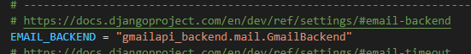

By default, the email background in the local environment is set to **console**. This means that the email will be printed to the console, rather than sent to any actual address. This is preferable for a development environment where we don’t have or need actual API keys, but is not representative of the production version.

In order to test the Gmail API backend, make sure that the package is installed in your environment. It must then be added as a third-party app in the Django config, and then finally set as the email backend. By configuring the three variables mentioned earlier, the program will begin to send emails through the authenticated account associated with those tokens automatically.